Solution Architecture Document
[Project Name / Code Name]

Author: [Your Name/Role]
Date: [DD/MM/YYYY]
Version: [1.2.0]
Classification: [e.g., OFFICIAL-SENSITIVE / INTERNAL]

Document Control

Revision History
Version | Date | Author | Summary of Changes
0.1 | DD/MM/YYYY | [Name] | Initial Draft for Review

Approvals
Role | Name | Signature | Date
Project Sponsor

[Notes for use of document:]
- This template contains placeholders for all diagrams, if a diagram is not required for a given project delete the sections and placeholders for diagrams that are not relevant to your specific project scope to avoid overcomplicating the design.
- The document formatting follows paragraph number for ease of review and external commenting documentation. There are 3 levels of headings to allow better organization of data within the document. This will mean that paragraph data should start when the numbering follows this patten X.X.X.X (X referring to the paragraph/section numbers).
- Where wording in the template is written like “This is placeholder text colure” then this should be replaced with information for your project and not left in the document.
- Depending on the solution, you may require more than one of the same types of diagram if this is the case then create subheading using the X.X.X numbering for each type of diagram.
- The example diagrams have been created with Archi but use which ever visual design application that is available to your company such as Visio, Draw.IO etc.
- This template is a foundational baseline for architectural governance. Architects and technical leads are expected to adapt, expand, and tailor these sections to align with the specific compliance frameworks, security policies, and operational standards unique to their organization and project scope.

Contents
1 Document Control 2
1.1 Revision History 2
1.2 Approvals 2
2 Executive Summary 7
3 Business Architecture (The 'Why') 8
3.2 Business Footprint Diagram 8
3.3 Business Services and Information Diagram 9
3.4 Functional Decomposition Diagram 9
3.5 Product Lifecycle Diagram 10
3.6 Goal/Objective/Business Service Diagram 10
3.7 Business Use-Case Diagram 11
3.8 Organisation Decomposition Diagram 12
3.9 Process Flow Diagram 12
3.10 Business Event Diagram 13
3.11 Business Capability Map 13
3.12 Value Stream Map 14
3.13 Organisation Map 15
3.14 Information Map 15
4 Data Architecture (The 'What') 16
4.2 Conceptual Data Diagram 16
4.3 Logical Data Diagram 16
4.4 Data Dissemination Diagram 17
4.5 Data Security Diagram 17
4.6 Data Migration Diagram 18
4.7 Data Lifecycle Diagram 18
5 Application Architecture (The 'How') 19
5.2 Application Communication Diagram 19
5.3 Application and User Location Diagram 20
5.4 Application Use-Case Diagram 20
5.5 Enterprise Manageability Diagram 21
5.6 Process/Application Realisation Diagram 21
5.7 Software Engineering Diagram 22
5.8 Application Migration Diagram 22
5.9 Software Distribution Diagram 23
6 Technology Architecture (The 'Where') 24
6.2 Environments and Location Diagram 24
6.3 Platform Decomposition Diagram 25
6.4 Processing Diagram 25
6.5 Networked Computing / Hardware Diagram 26
6.6 Network and Communications Diagram 27
6.7 Resource Sizing & Bill of Materials (BoM) 28

Table of Figures
Figure 1 - Business Footprint Diagram 8
Figure 2 - Business Services and Information Diagram 9
Figure 3 - Functional Decomposition Diagram 9
Figure 4 - Product Lifecycle Diagram 10
Figure 5 - Goal/Objective/Business Service Diagram 10
Figure 6 - Business Use-Case Diagram 11
Figure 7 - Organisation Decomposition Diagram 12
Figure 8 - Process Flow Diagram 12
Figure 9 - Business Event Diagram 13
Figure 10 - Business Capability Map 13
Figure 11 - Value Stream Map 14
Figure 12 - Organisation Map 15
Figure 13 - Information Map 15
Figure 14 - Conceptual Data Diagram 16
Figure 15 - Logical Data Diagram 16
Figure 16 - Data Dissemination Diagram 17
Figure 17 - Data Security Diagram 17
Figure 18 - Data Migration Diagram 18
Figure 19 - Data Lifecycle Diagram 18
Figure 20 - Application Communication Diagram 19
Figure 21 - Application and User Location Diagram 20
Figure 22 - Application Use-Case Diagram 20
Figure 23 - Enterprise Manageability Diagram 21
Figure 24 - Process/Application Realisation Diagram 21
Figure 25 - Software Engineering Diagram 22
Figure 26 - Application Migration Diagram 22
Figure 27 - Software Distribution Diagram 23
Figure 28 - Environments and Location Diagram 24
Figure 29 - Platform Decomposition Diagram 25
Figure 30 - Processing Diagram 25
Figure 31 - Networked Computing / Hardware Diagram 26
Figure 32 - Network and Communications Diagram 27

Table of Tables
Table 1 - Table of Acronyms 6
Table 2 - Resource Sizing & BoM 28

Table of Acronyms
Acronym | Definition
Table 1 - Table of Acronyms

Executive Summary

Provide a high-level summary of the solution, written for a non-technical executive audience.

Business Architecture (The 'Why')

This section demonstrates how the technical design supports specific business capabilities and services.

Business Footprint Diagram

A hierarchical map connecting high-level business capabilities and / or business services down to the specific application functions being deployed.
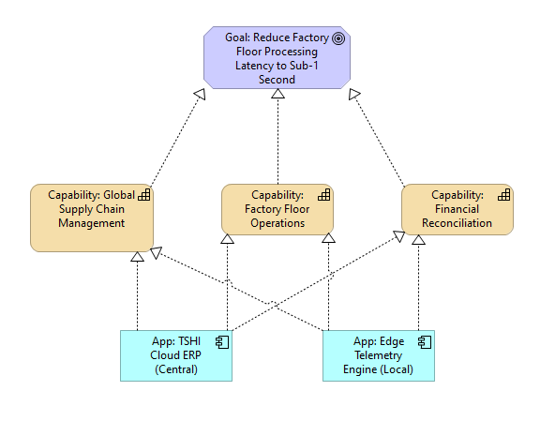
Figure 1 - Business Footprint Diagram

Explain what is depicted in the diagram and detail any important information that supports the what the diagram is showing.

Business Services and Information Diagram

A direct mapping between specific Business Services and the high-level Information Entities or Data Objects they consume, create, or modify.
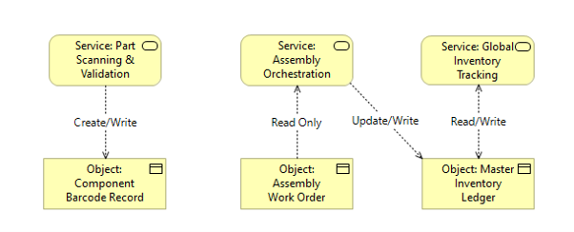
Figure 2 - Business Services and Information Diagram

Explain what is depicted in the diagram and detail any important information that supports the what the diagram is showing.

Functional Decomposition Diagram

A hierarchical tree that breaks down a broad, complex business area into its smaller, constituent sub-functions.
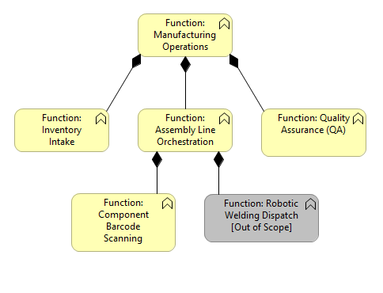
Figure 3 - Functional Decomposition Diagram

Explain what is depicted in the diagram and detail any important information that supports the what the diagram is showing.

Product Lifecycle Diagram

A high-level view of the end-to-end product journey, highlighting exactly where the deployed solution sits within that journey.
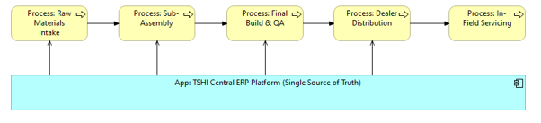
Figure 4 - Product Lifecycle Diagram

Explain what is depicted in the diagram and detail any important information that supports the what the diagram is showing.

Goal/Objective/Business Service Diagram

A strategic alignment map that traces top-level corporate or project Goals down to specific, measurable Objectives, and finally links them to the actionable Business Services.
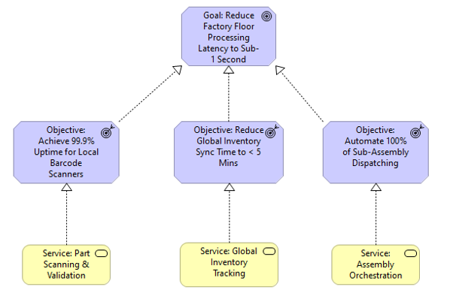
Figure 5 - Goal/Objective/Business Service Diagram

Explain what is depicted in the diagram and detail any important information that supports the what the diagram is showing.

Business Use-Case Diagram

A high-level mapping of the key actors and the core business activities or value streams they need to execute within the boundary of the new system.
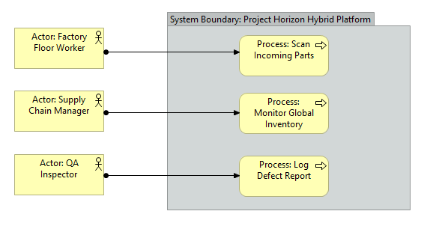
Figure 6 - Business Use-Case Diagram

Explain what is depicted in the diagram and detail any important information that supports the what the diagram is showing.

Organisation Decomposition Diagram

A hierarchical 'org chart' of the enterprise, breaking down the business from the highest executive level down to the individual roles interacting with the deployed system.
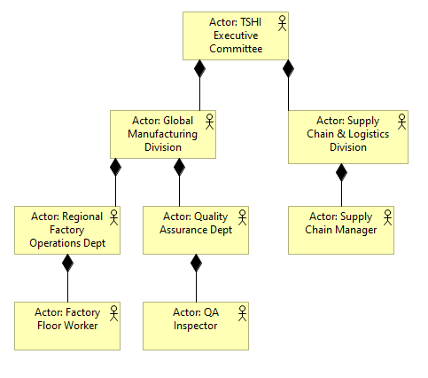
Figure 7 - Organisation Decomposition Diagram

Explain what is depicted in the diagram and detail any important information that supports the what the diagram is showing.

Process Flow Diagram

A sequential, step-by-step visual representation of a specific business operation or user journey using swim lanes.
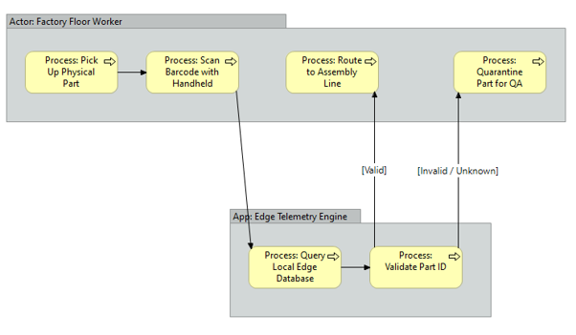
Figure 8 - Process Flow Diagram

Explain what is depicted in the diagram and detail any important information that supports the what the diagram is showing.

Business Event Diagram

A map of the specific, real-world 'triggers' (Events) that force the business to act, and the subsequent processes or services that respond to them.
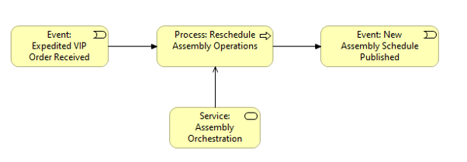
Figure 9 - Business Event Diagram

Explain what is depicted in the diagram and detail any important information that supports the what the diagram is showing.

Business Capability Map

A high-level, technology-independent matrix of the organization's core abilities.
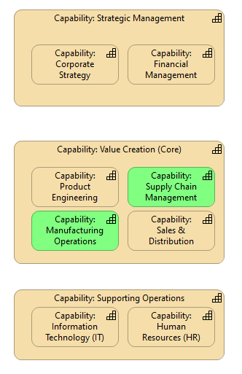
Figure 10 - Business Capability Map

Explain what is depicted in the diagram and detail any important information that supports the what the diagram is showing.

Value Stream Map

The end-to-end, step-by-step sequence of activities required to deliver a specific product, service, or piece of value to a customer.
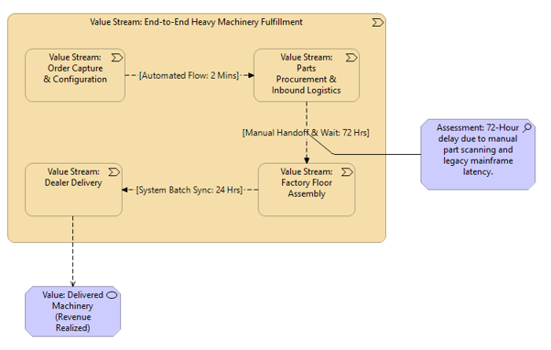
Figure 11 - Value Stream Map

Explain what is depicted in the diagram and detail any important information that supports the what the diagram is showing.

Organisation Map

A visual representation of the key business units, geographic locations, and external partners, highlighting the lines of collaboration and data sharing between them.
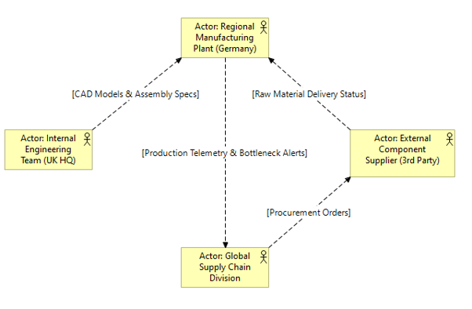
Figure 12 - Organisation Map

Explain what is depicted in the diagram and detail any important information that supports the what the diagram is showing.

Information Map

A high-level, business-friendly taxonomy of the data the organization cares about.
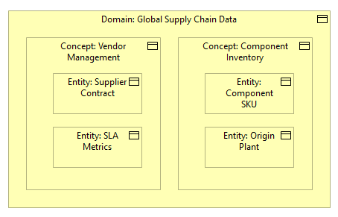
Figure 13 - Information Map

Explain what is depicted in the diagram and detail any important information that supports the what the diagram is showing.

Data Architecture (The 'What')

This section demonstrates how the technical design supports specific business capabilities and services.

Conceptual Data Diagram

A high-level, completely technology-agnostic map of the core business 'things' (Entities) and the rules governing how they relate to each other.
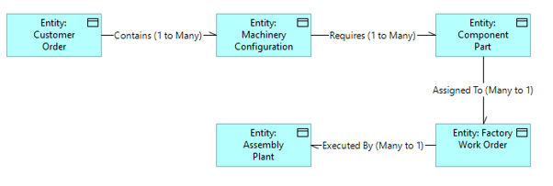
Figure 14 - Conceptual Data Diagram

Explain what is depicted in the diagram and detail any important information that supports the what the diagram is showing.

Logical Data Diagram

A structured map of data entities, their specific attributes, and the precise rules/cardinality governing their relationships.
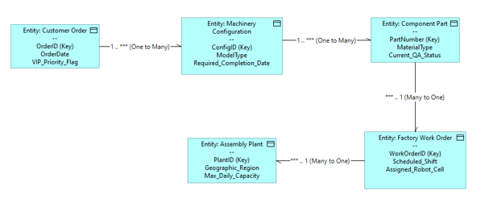
Figure 15 - Logical Data Diagram

Explain what is depicted in the diagram and detail any important information that supports the what the diagram is showing.

Data Dissemination Diagram

A map of how data physically or logically moves from a central authoritative source out to consuming applications and external systems.
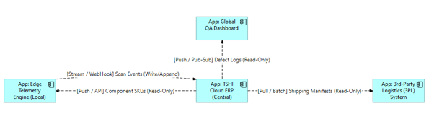
Figure 16 - Data Dissemination Diagram

Explain what is depicted in the diagram and detail any important information that supports the what the diagram is showing.

Data Security Diagram

A visual representation of the concentric 'Defence-in-Depth' security controls protecting the core data payload.
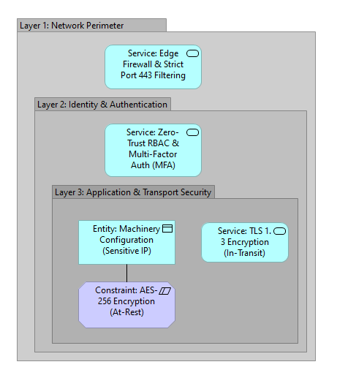
Figure 17 - Data Security Diagram

Explain what is depicted in the diagram and detail any important information that supports the what the diagram is showing.

Data Migration Diagram

A phased, chronological map detailing how legacy information is Extracted, Transformed, and Loaded (ETL) into the target environment.
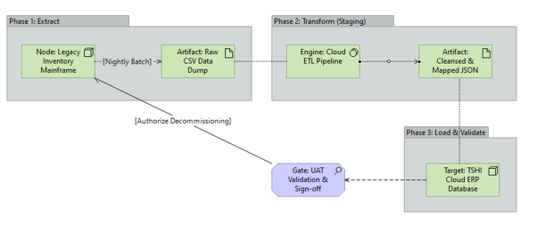
Figure 18 - Data Migration Diagram

Explain what is depicted in the diagram and detail any important information that supports the what the diagram is showing.

Data Lifecycle Diagram

A state-machine view of how a critical piece of information evolves over time from creation to retirement.
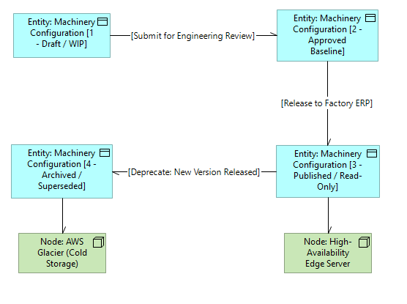
Figure 19 - Data Lifecycle Diagram

Explain what is depicted in the diagram and detail any important information that supports the what the diagram is showing.

Application Architecture (The 'How')

This section defines the logical software components, their integrations, and how they execute the business services.

Application Communication Diagram

A logical map of the software components and the exact communication pathways between them, detailing protocols and ports.
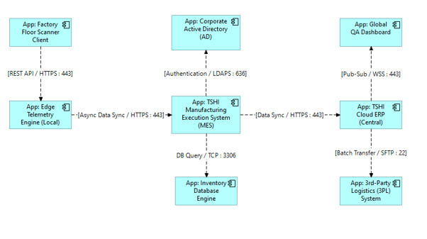
Figure 20 - Application Communication Diagram

Explain what is depicted in the diagram and detail any important information that supports the what the diagram is showing.

Application and User Location Diagram

A geographical or logical site map overlaying where the software applications are hosted against the physical locations of the end-users accessing them.
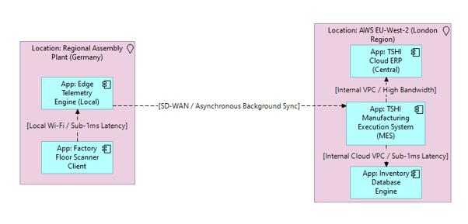
Figure 21 - Application and User Location Diagram

Explain what is depicted in the diagram and detail any important information that supports the what the diagram is showing.

Application Use-Case Diagram

A mapping of specific actors to the exact software functions they execute within the application boundary.
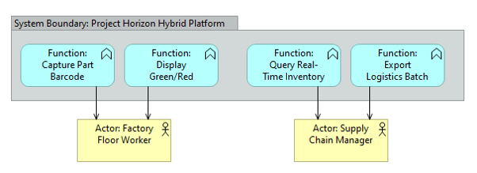
Figure 22 - Application Use-Case Diagram

Explain what is depicted in the diagram and detail any important information that supports the what the diagram is showing.

Enterprise Manageability Diagram

A hub-and-spoke map placing the core application in the centre and surrounding it with the specific IT Service Management (ITSM) and operational domains required to keep it running.
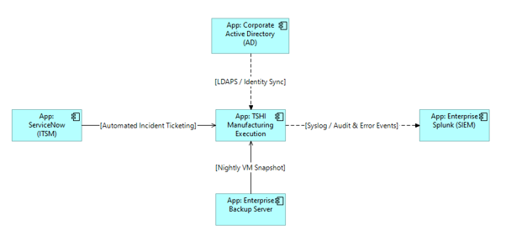
Figure 23 - Enterprise Manageability Diagram

Explain what is depicted in the diagram and detail any important information that supports the what the diagram is showing.

Process/Application Realisation Diagram

A multi-layered mapping that explicitly links the deployed software components upward to the specific business workflows they execute.
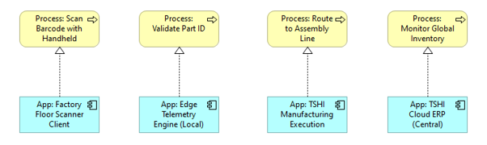
Figure 24 - Process/Application Realisation Diagram

Explain what is depicted in the diagram and detail any important information that supports the what the diagram is showing.

Software Engineering Diagram

The internal structural blueprint of a custom-built software application detailing code modules, classes, and APIs.
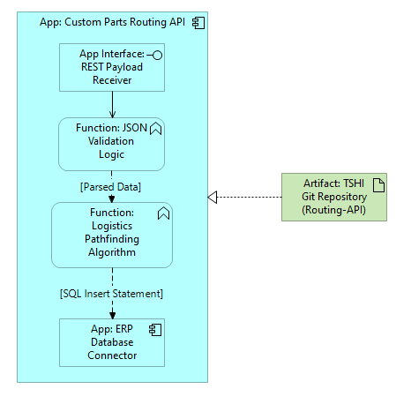
Figure 25 - Software Engineering Diagram

Explain what is depicted in the diagram and detail any important information that supports the what the diagram is showing.

Application Migration Diagram

A visual timeline of how legacy applications are retired and replaced, showing user traffic and routing shifts.
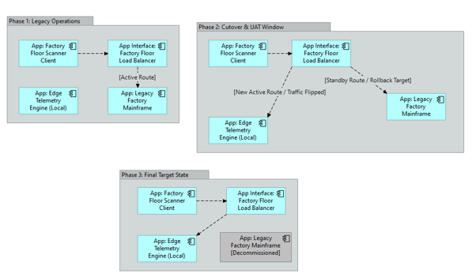
Figure 26 - Application Migration Diagram

Explain what is depicted in the diagram and detail any important information that supports the what the diagram is showing.

Software Distribution Diagram

A supply-chain map tracking how raw software binaries move from the external vendor into the secure environment via staging areas and automation tools.
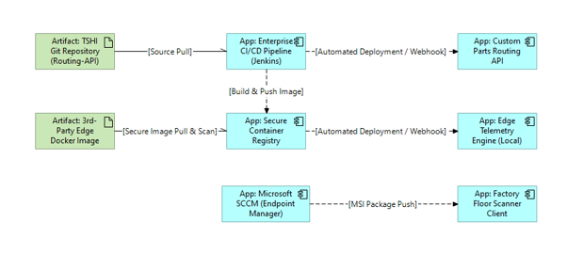
Figure 27 - Software Distribution Diagram

Explain what is depicted in the diagram and detail any important information that supports the what the diagram is showing.

Technology Architecture (The 'Where')

This section maps the logical software requirements down to tangible IT infrastructure.

Environments and Location Diagram

A map of the physical data centres, underlying hardware, and how logical environments are distributed across them.
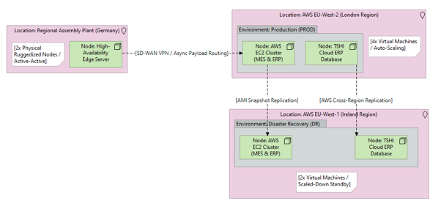
Figure 28 - Environments and Location Diagram

Explain what is depicted in the diagram and detail any important information that supports the what the diagram is showing.

Platform Decomposition Diagram

A vertical 'stack' model that deconstructs the IT solution into strict technological layers from physical hardware up to end-user interfaces.
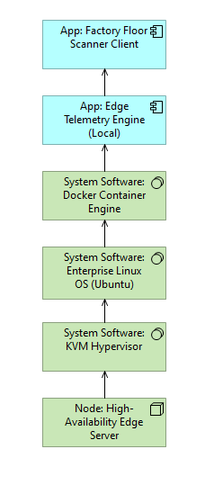
Figure 29 - Platform Decomposition Diagram

Explain what is depicted in the diagram and detail any important information that supports the what the diagram is showing.

Processing Diagram

A cross-functional map tracking the computational workload of specific transactions as they traverse the physical IT infrastructure.
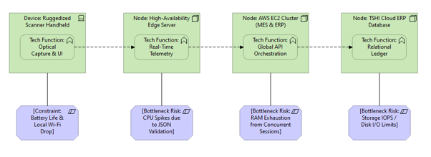
Figure 30 - Processing Diagram

Explain what is depicted in the diagram and detail any important information that supports the what the diagram is showing.

Networked Computing / Hardware Diagram

A strict, zone-based network topology map segmenting the infrastructure into logical security tiers separated by firewalls.
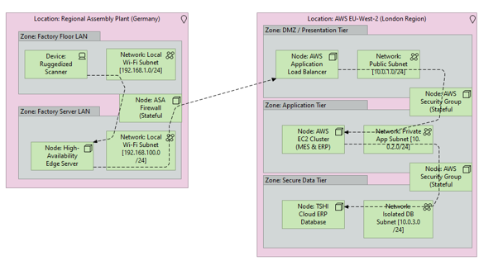
Figure 31 - Networked Computing / Hardware Diagram

Explain what is depicted in the diagram and detail any important information that supports the what the diagram is showing.

Network and Communications Diagram

A macro-level map of the physical and Wide-Area Network (WAN) links connecting geographically dispersed sites, data centres, and external gateways.
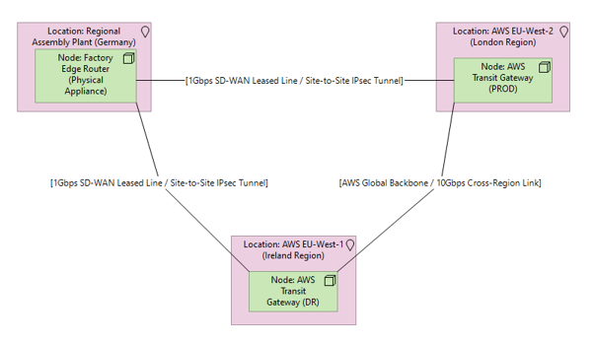
Figure 32 - Network and Communications Diagram

Explain what is depicted in the diagram and detail any important information that supports the what the diagram is showing.

Resource Sizing & Bill of Materials (BoM)

This section explicitly defines the compute, memory, and storage specifications required to host the solution.

Details in the table below are examples and can be deleted.
Node / Hostname | Architectural Role | Operating System | Compute (Sockets / Cores / vCPU) | Min Clock Speed | RAM | Storage Allocation | Storage Tier
GB1-App-01 | Active App Server | RHEL 9 | 8 Cores (or 8 vCPU) | 2.5 GHz+ | 32 GB | 100 GB (OS) | Standard Enterprise SAN
GB1-DB-01 | Primary Database | RHEL 9 | 16 Cores (or 16 vCPU) | 3.0 GHz+ | 64 GB | 100 GB (OS)  500 GB (Data/Indexes) | SSD / Fast Tier
DR-App-01 | Standby App Server | RHEL 9 | 8 Cores (or 8 vCPU) | 2.5 GHz+ | 32 GB | 100 GB (OS) | Standard Enterprise SAN
DR-DB-01 | Primary Database | RHEL 9 | 16 Cores (or 16 vCPU) | 3.0 GHz+ | 64 GB | 100 GB (OS)  500 GB (Data/Indexes) | Standard Enterprise SAN
Table 2 - Resource Sizing & BoM

