Low-Level Design (LLD) / Detailed Design Document
[Project Name / Code Name]

Author: [Your Name/Role]
Date: [DD/MM/YYYY]
Version: [1.0.0]
Classification: [e.g., OFFICIAL-SENSITIVE / INTERNAL]

Document Control

Revision History
Version | Date | Author | Summary of Changes
0.1 | DD/MM/YYYY | [Name] | Initial Draft for Review

Approvals
Role | Name | Signature | Date
Project Sponsor

[Notes for use of document:]
- This Low-Level Design (LLD) is the step-by-step assembly manual. It is aimed directly at Build Teams, Network Administrators, and DBAs. Do NOT include strategic business context, value streams, or conceptual diagrams. Leave absolutely nothing to the imagination. Provide exact configurations.
- If any configuration table in this section exceeds 20 rows (e.g., provisioning 50 VMs or writing 100 firewall rules), remove the table from this document. Document the logic there and move the raw tabular data to the external Build Matrix spreadsheet.
- The document formatting follows paragraph number for ease of review and external commenting documentation. There are 3 levels of headings to allow better organization of data within the document. This will mean that paragraph data should start when the numbering follows this patten X.X.X.X (X referring to the paragraph/section numbers).
- Where wording in the template is written like “This is placeholder text colure” then this should be replaced with information for your project and not left in the document.
- Depending on the solution, you may require more than one of the same types of diagrams if this is the case then create subheading using the X.X.X numbering for each type of diagram.
- The example diagrams have been created with Archi but use which ever visual design application that is available to your company such as Visio, Draw.IO etc.
- This template is a foundational baseline for architectural governance. Architects and technical leads are expected to adapt, expand, and tailor these sections to align with the specific compliance frameworks, security policies, and operational standards unique to their organization and project scope.

Contents
1 Document Control 2
1.1 Revision History 2
1.2 Approvals 2
2 Parent Architecture & Scope 6
3 Network & Connectivity Configuration 7
3.2 Networked Computing / Hardware Diagram 7
3.3 Network and Communications Diagram 8
4 Compute & Infrastructure Configuration 9
4.2 Platform Decomposition Diagram 9
5 Application Tuning & Performance 11
5.2 Processing Diagram 11
6 High-Availability & Disaster Recovery Mechanics 12
6.2 Environments and Location Diagram 12
7 Configuration Build Matrix 14

Table of Figures
Figure 1 - Networked Computing / Hardware Diagram 6
Figure 2 - Network and Communications Diagram 7
Figure 3 - Platform Decomposition Diagram 8
Figure 4 - Processing Diagram 10
Figure 5 - Environments and Location Diagram 11

Table of Tables
Table 1 - Table of Acronyms 5
Table 2 - VLAN Details 7
Table 3 - Routing Details 7
Table 4 - NAT / PAT Translation Details 8
Table 5 - Virtual Machine / Physical Host Build Details 9
Table 6 - Storage / LUN Mapping Details 10
Table 7 - Service Account & RBAC Details 10
Table 8 - Load Balancer (ADC) Configuration Details 12
Table 9 - Cluster Mechanics Details 13
Table of Acronyms
Acronym | Definition
Table 1 - Table of Acronyms

Parent Architecture & Scope

Briefly state what is being built and reference the parent Solution Architecture Document (SAD) that governs this design. Do not explain business justifications here.

Network & Connectivity Configuration

Detail the exact IP schemas, subnets, VLAN tags, routing protocols (e.g., BGP ASNs), and explicit NAT translation rules required to build the network.

Networked Computing / Hardware Diagram

A strict, zone-based network topology map segmenting the infrastructure into logical security tiers separated by firewalls.
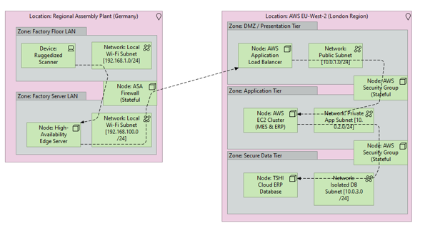
Figure 1 - Networked Computing / Hardware Diagram

Explain what is depicted in the diagram and detail any important information that supports the what the diagram is showing.
VLAN Name | IP Range | Subnet Mask | Gateway | Range Start | Range Finish
Table 2 - VLAN Details
Destination Network | Subnet Mask | Next Hop / Gateway | Interface | Metric / ASN
Table 3 - Routing Details
Original Source IP | Translated Source IP | Original Dest IP | Translated Dest IP | Port | Direction (In/Out)
Table 4 - NAT / PAT Translation Details
Rule Name/ID | Source (IP/Subnet) | Destination (IP/Subnet) | Port | Protocol (TCP/UDP) | Action (Allow/Deny)
Table 5 - Localized Firewall & Security Group Rules

Network and Communications Diagram

A macro-level map of the physical and Wide-Area Network (WAN) links connecting geographically dispersed sites, data centres, and external gateways.
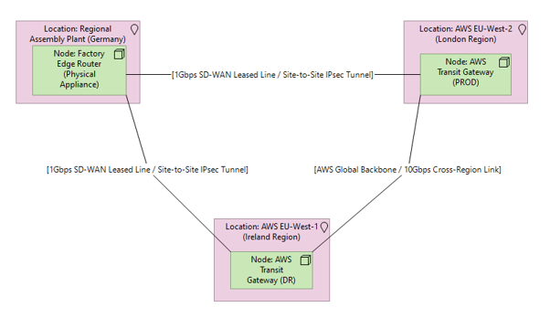
Figure 2 - Network and Communications Diagram

Explain what is depicted in the diagram and detail any important information that supports the what the diagram is showing.

Compute & Infrastructure Configuration

Provide component-level instructions: specific registry keys, exact service account names (excluding passwords), local group policies, and hypervisor allocations.

Platform Decomposition Diagram

A vertical 'stack' model that deconstructs the IT solution into strict technological layers from physical hardware up to end-user interfaces.
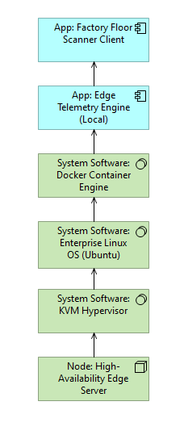
Figure 3 - Platform Decomposition Diagram

Explain what is depicted in the diagram and detail any important information that supports the what the diagram is showing.
Hostname | OS Version | CPU | RAM | Storage (Tier & Size) | Network (VLAN Name) | Primary IP
Table 6 - Virtual Machine / Physical Host Build Details
Volume/LUN Name | Size (GB/TB) | Datastore/Mount Point | Storage Tier (NVMe/SSD) | Host WWN / IQN (If iSCSI/FC)
Table 7 - Storage / LUN Mapping Details
Account Name | Domain/Scope | Local Group Membership (e.g., Local Admin, IIS_IUSRS) | Target Service (e.g., SQL Server Engine) | Password Vault Location (e.g., CyberArk ID)
Table 8 - Service Account & RBAC Details
Record Type (A, CNAME, PTR) | Hostname (FQDN) | Target IP / Alias | TTL
Table 9 - DNS & IPAM Requirements
Common Name (CN) | Subject Alternative Names (SANs) | Issuing CA (Internal/External) | Key Length (e.g., RSA 2048) | Format (PEM/PFX)
Table 10 - SSL/TLS Certificate Requirements

Application Tuning & Performance

Detail software dependencies, Java heap sizes, database memory allocations, and application-specific tuning parameters.

Processing Diagram

A cross-functional map tracking the computational workload of specific transactions as they traverse the physical IT infrastructure.
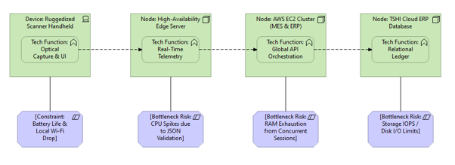
Figure 4 - Processing Diagram

Explain what is depicted in the diagram and detail any important information that supports the what the diagram is showing.
Target Node/Service | Parameter Name (e.g., innodb_buffer_pool_size, JVM -Xmx) | Configured Value | Default Value | Justification
Table 11 - Component Tuning & Parameter Overrides

High-Availability & Disaster Recovery Mechanics

Define the literal cluster configurations, heartbeat network IPs, load-balancer health-check parameters, and failover timeout values (e.g., 5-second polling, 3-miss threshold).

Environments and Location Diagram

A map of the physical data centres, underlying hardware, and how logical environments are distributed across them.
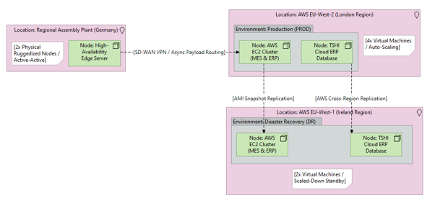
Figure 5 - Environments and Location Diagram

Explain what is depicted in the diagram and detail any important information that supports the what the diagram is showing.
Virtual IP (VIP) Name | VIP Address & Port | Backend Pool Nodes | Load Balancing Method (Round Robin, Least Conn) | Health Check (e.g., HTTP 200 on /healthz) | SSL Offload (Y/N)
Table 12 - Load Balancer (ADC) Configuration Details
Cluster Name | Quorum/Witness IP | Failover Timeout (ms) | Heartbeat Network (VLAN) | DRS/Affinity Rules (e.g., "Keep VMs Apart")
Table 13 - Cluster Mechanics Details
Target Server / Volume | Backup Tool/Agent | Policy/Schedule Name | Retention Period (e.g., 30 Days)

Configuration Build Matrix

For massive, repetitive configurations (like provisioning 50 identical web servers or writing 200 firewall rules), outline the logic of the configuration below, and explicitly reference the attached Configuration Spreadsheet for the raw, row-by-row data.

Attached Build Matrices:
[e.g., Firewall_Rule_Matrix_v1.0.xlsx]
[e.g., VM_Provisioning_Inventory_v1.0.xlsx]

