High-Level Design (HLD) / Conceptual Document
[Project Name / Code Name]

Author: [Your Name/Role]
Date: [DD/MM/YYYY]
Version: [1.1.0]
Classification: [e.g., OFFICIAL-SENSITIVE / INTERNAL]

Document Control

Revision History
Version | Date | Author | Summary of Changes
0.1 | DD/MM/YYYY | [Name] | Initial Draft for Review

Approvals
Role | Name | Signature | Date
Project Sponsor

[Notes for use of document:]
- This High-Level Design (HLD) is your strategic foundation. It bridges the business problem to a technical reality. Do not dictate underlying physical hardware, IP subnets, exact port numbers, or write a single line of code in this document.
- This template contains placeholders for all Phase 1-3 conceptual diagrams. If a diagram is not required for a given project, delete the sections and placeholders to avoid overcomplicating the design.
- The document formatting follows paragraph number for ease of review and external commenting documentation. There are 3 levels of headings to allow better organization of data within the document. This will mean that paragraph data should start when the numbering follows this patten X.X.X.X (X referring to the paragraph/section numbers).
- Where wording in the template is written like “This is placeholder text colure” then this should be replaced with information for your project and not left in the document.
- Depending on the solution, you may require more than one of the same types of diagrams if this is the case then create subheading using the X.X.X numbering for each type of diagram.
- The example diagrams have been created with Archi but use which ever visual design application that is available to your company such as Visio, Draw.IO etc.
- This template is a foundational baseline for architectural governance. Architects and technical leads are expected to adapt, expand, and tailor these sections to align with the specific compliance frameworks, security policies, and operational standards unique to their organization and project scope.

Contents
1 Document Control 2
1.1 Revision History 2
1.2 Approvals 2
2 Executive Summary 5
2.2 Strategic Architectural Principles 5
3 Business Architecture (The 'Why') 6
3.2 Business Services and Information Diagram 6
3.3 Goal/Objective/Business Service Diagram 7
3.4 Business Capability Map 8
3.5 Value Stream Map 9
4 Data Architecture (The 'What') 10
4.2 Conceptual Data Diagram 10
4.3 Data Dissemination Diagram 10
4.4 Data Security Diagram 11
5 Application Architecture (The 'How') 12
5.2 Application Communication Diagram 12

Table of Figures
Figure 1 - Business Services and Information Diagram 6
Figure 2 - Goal/Objective/Business Service Diagram 7
Figure 3 - Business Capability Map 8
Figure 4 - Value Stream Map 9
Figure 5 - Conceptual Data Diagram 10
Figure 6 - Data Dissemination Diagram 10
Figure 7 - Data Security Diagram 11
Figure 8 - Application Communication Diagram 12

Table of Tables
Table 1 - Table of Acronyms 4

Table of Acronyms
Acronym | Definition
Table 1 - Table of Acronyms

Executive Summary

Provide a high-level summary of the solution, written for a non-technical executive audience, Project Sponsors, and Financial Controllers. Explain the core business problem and the proposed conceptual solution.

Strategic Architectural Principles

Detail the key architectural principles and constraints governing this design. e.g., 'We are prioritizing a cloud-native PaaS approach for scalability,' or 'This solution must adhere to a strict Zero-Trust logical boundary.'

Business Architecture (The 'Why')

This section defines the core problem and proves exactly which business functions this project supports. It is aimed at C-Suite Executives and Business Unit Leads.

Business Services and Information Diagram

A direct mapping between specific Business Services and the high-level Information Entities or Data Objects they consume, create, or modify.
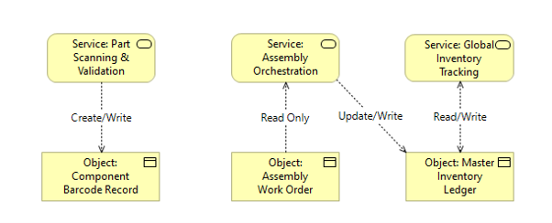
Figure 1 - Business Services and Information Diagram

Explain what is depicted in the diagram and detail any important information that supports the what the diagram is showing.

Goal/Objective/Business Service Diagram

A strategic alignment map that traces top-level corporate or project Goals down to specific, measurable Objectives, and finally links them to the actionable Business Services.
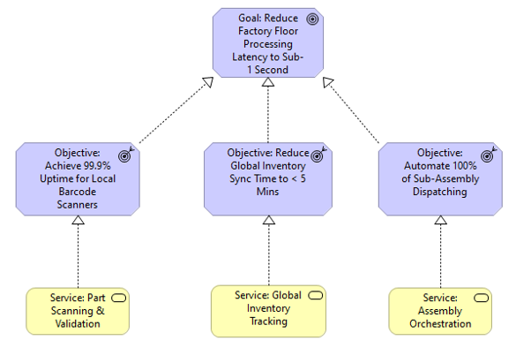
Figure 2 - Goal/Objective/Business Service Diagram

Explain what is depicted in the diagram and detail any important information that supports the what the diagram is showing.

Business Capability Map

A high-level, technology-independent matrix of the organization's core abilities.
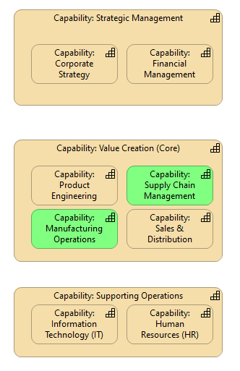
Figure 3 - Business Capability Map

Explain what is depicted in the diagram and detail any important information that supports the what the diagram is showing.

Value Stream Map

The end-to-end, step-by-step sequence of activities required to deliver a specific product, service, or piece of value to a customer.
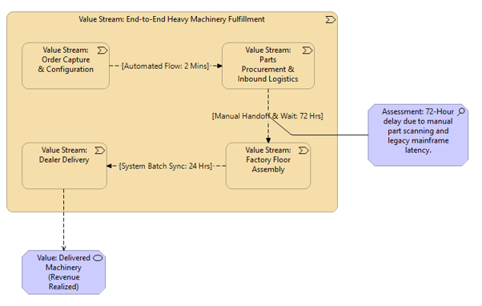
Figure 4 - Value Stream Map

Explain what is depicted in the diagram and detail any important information that supports the what the diagram is showing.

Data Architecture (The 'What')

This section demonstrates how the technical design supports specific business capabilities and services.

Conceptual Data Diagram

A high-level, completely technology-agnostic map of the core business 'things' (Entities) and the rules governing how they relate to each other.
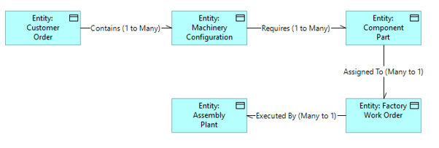
Figure 5 - Conceptual Data Diagram

Explain what is depicted in the diagram and detail any important information that supports the what the diagram is showing.

Data Dissemination Diagram

A map of how data physically or logically moves from a central authoritative source out to consuming applications and external systems.
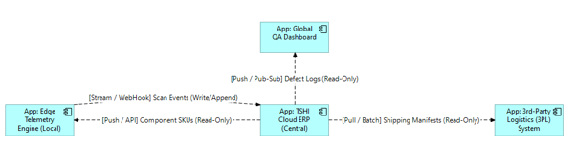
Figure 6 - Data Dissemination Diagram

Explain what is depicted in the diagram and detail any important information that supports the what the diagram is showing.

Data Security Diagram

A visual representation of the concentric 'Defence-in-Depth' security controls protecting the core data payload.
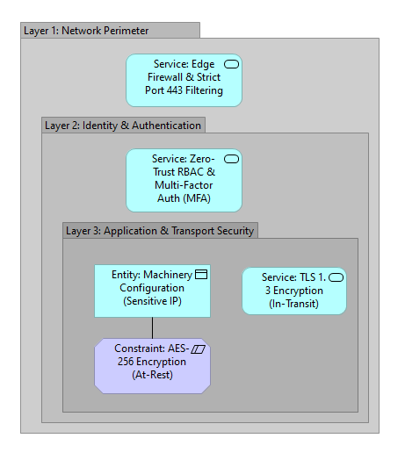
Figure 7 - Data Security Diagram

Explain what is depicted in the diagram and detail any important information that supports the what the diagram is showing.

Application Architecture (The 'How')

This section defines the logical software components, their integrations, and how they execute the business services.

Application Communication Diagram

A logical map of the software components and the exact communication pathways between them, detailing protocols and ports.

CRITICAL HLD RULE: At this stage, only map the logical system connections. Intentionally hold off on adding granular port numbers and protocols (e.g., do not add 'TCP 3306' yet). Those details belong in the SAD.
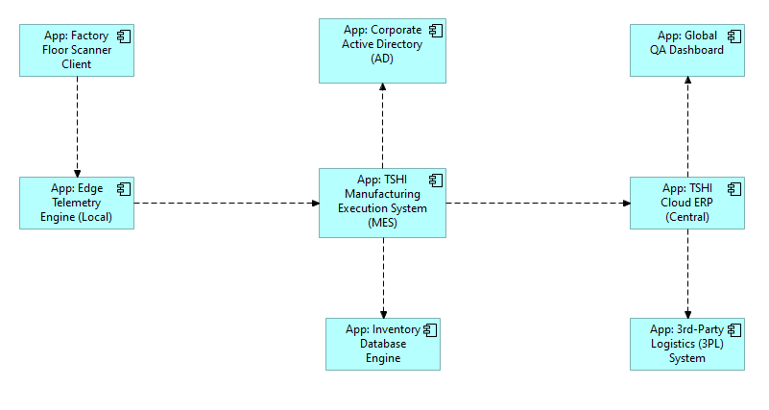
Figure 8 - Application Communication Diagram

Explain what is depicted in the diagram and detail any important information that supports the what the diagram is showing.

